MILC
Anaphylaxis Emergency Response Procedure

Purpose

This details an emergency procedure to treat any person at MILC who is suffering an anaphylactic reaction. This procedure applies to all School Employees and students at MILC.

Clinical Presentation of Possible Allergic and Anaphylactic Reaction

- Common symptoms of a mild to moderate allergic reaction include hives, welts or body redness, swelling of the face, lips or eyes.
- Signs of severe allergic reaction include vomiting, abdominal pain, tingling of the mouth.
- Signs of a severe allergic anaphylactic reaction include:

- difficult and/or noisy breathing;
- swelling of the tongue;
- swelling or tightness in the throat;
- difficulty talking and/or hoarse voice;
- wheeze or persistent cough;
- persistent dizziness or collapsing; or
- pale and floppy (particularly in younger children).

Anaphylaxis Emergency Response Procedure

  - Lay person flat - do not allow person to stand or walk.
  - If unconscious, place them in the recovery position.
  - If breathing is difficult allow them to sit up.
  - Administer Epipen auto-injector. If there is doubt about the diagnosis still administer the Epipen auto-injector.
  - Note the time that it was administered.
  - Call Emergency Services (000) and follow instructions.
  - Monitor patient and notify other staff to assist if available.
  - Commence Cardiopulmonary resuscitation (CPR) if at any time the patient is unresponsive and/or not breathing.
  - Further adrenaline may be administered as required if the patient deteriorates.
  - Transfer patient to hospital via ambulance along with any discharged Epipen auto injector(s).
  - Ensure parents/relatives/carer is notified.

Position of First Aid Kits and Epipens at MILC

1 One mobile First Aid kit with EpiPen is available at the reception for excursions, the kit is to take out with the group.
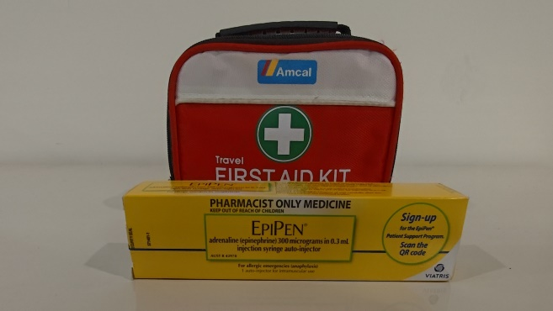
2 One First Aid box is fixed to the wall on the ground floor along the corridor.
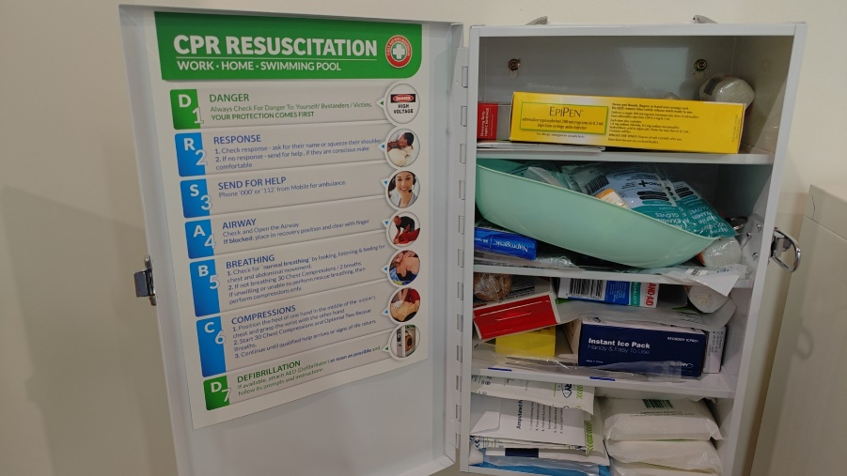
3 One First Aid kit with EpiPens is in the kitchen on the side of the kitchen door in the basement.
