MILC
Allergy and Anaphylaxis Management Policy

Purpose

The purpose of this Policy is to provide the framework and guidance for the management of allergies and anaphylaxis at MILC following guidelines related to anaphylaxis management in schools as published and amended by DET from time to time.

Commitment

MILC is committed to:

- being Allergy aware, to ensure that students, employees and parents/legal guardians are familiar with some common, serious allergies and know how to manage an allergic reaction. Every effort is made to reduce the risks associated with allergies, however it cannot be guaranteed that MILC is ‘free’ of any particular product;
- providing, as far as practicable, a safe and supportive environment in which students at risk of anaphylaxis can participate equally in all aspects of their schooling;
- raising awareness about anaphylaxis and MILC’s anaphylaxis management policy in the MILC community;
- engaging with parents/legal guardians of students at risk of anaphylaxis in assessing risks, developing risk minimisation strategies and management strategies for the student; and
- ensuring that each MILC employee has adequate knowledge about allergies, anaphylaxis and MIL’s policy and procedures in responding to an anaphylactic reaction.

Individual Anaphylaxis Management Plans

- MILC management will ensure that an individual management plan is developed, in consultation with the student’s parents/legal guardians, for any student who has been diagnosed by a medical practitioner as being at risk of anaphylaxis.
- The individual anaphylaxis management plan will be in place as soon as practicable after the student’s enrolment, and where possible before their first day of school.
- The individual anaphylaxis management plan will set out the following:
- information about the diagnosis, including the type of allergy or allergies the student has (based on a diagnosis from a medical practitioner);
- strategies to minimise the risk of exposure to allergens while the At Risk Student is under the care or supervision of school employees, for in-school and out of school settings including camps and excursions;
- the name of the person/s responsible for implementing the strategies;
- information on where the At Risk Student’s medication will be stored;
- the student’s emergency contact details;
- an ACSIA Action Plan (or the overseas equivalent in English), provided by the parents/legal guardians, that sets out the emergency procedures to be taken in the event of an allergic reaction, is signed by a medical practitioner, and includes an up to date photograph of the student.

- The At Risk Student’s individual management plan will be reviewed, in consultation with the student’s parents/legal guardians:
- annually and as applicable;
- if the student’s condition changes;
- immediately after a At Risk Student has an anaphylactic reaction at school; and
- prior to any excursion or off Campus activity, by the Teacher in Charge of the excursion.
- It is the responsibility of the parents/legal guardians to:
- provide the At Risk Student’s ASCIA Action Plan;
- inform MILC if their child’s medical condition changes and, if relevant, provide an updated ASCIA Action Plan;
- provide an up to date photo for the ASCIA Action Plan when the plan is provided to MILC and when it is reviewed;
and
- provide MILC with an adrenaline auto-injector that is current and not expired.

Communication Procedure

- MILC management is responsible for ensuring that a communication procedure is developed to provide information to all employees, students and parents/legal guardians about Anaphylaxis and this Policy.
- The communication procedure includes information about what steps will be taken to respond to an anaphylactic reaction of an At Risk Student in a classroom, within the boarding premises, and on school excursions.
- Volunteers and casual relief employees will be informed by MILC management or nominee which At Risk Students and will be told how to respond to an At Risk Student in their care having an anaphylactic reaction.
- All applicable employees will be briefed every 6 months by another employee who has completed a course 22300VIC or 10313NAT in Anaphylaxis Management within the past 2 years.
- The first briefing must occur as close as is practicable to the start of the school year. Briefings must include the following information:

- explanation of this Policy;
- the causes, symptoms and treatment of Anaphylaxis;
- the identities of students diagnosed at risk of Anaphylaxis and where their medication is located;
- how to use an auto-adrenaline injecting device;
- MILC’s first aid and emergency response procedures;
- the location of School purchased generic auto-injectors.

School Employee Training

- All School teachers and other School employees who conduct classes which may contain At Risk Students, or give instruction to At Risk Students, must have accredited three (3) yearly training in an Anaphylaxis management training course or have
completed two (2) yearly training in the ASCIA on line e-learning module They must also be briefed twice a year by a person from within MILC who has completed course 22300VIC or 10313NAT in Anaphylaxis Management within the past two (2)
years.
- At other times, while the At Risk Student is under the care or supervision of MILC, including excursions, MILC management must ensure that there is a sufficient number of employees with up to date training in an anaphylaxis management training course to cover the excursion.
- MILC undertakes to provide anaphylaxis management training for all applicable School employees via accredited 22300VIC Anaphylaxis Management training:
- every three (3) years;
- ASCIA on line e-learning every two (2) years; and
- applicable internal briefings.
- Training records are maintained for all applicable employees.
- If for any reason Anaphylaxis accreditation has not occurred in accordance with the above schedule, then MILC management must develop an interim management plan in consultation with the parents of any affected At Risk Student. The accreditation must occur as soon as possible after MILC management becomes aware that it has not occurred.
- An interim management strategy will then be implemented by MILC management in consultation with the parents.
- If a person has missed an internal anaphylaxis briefing they will be requested to attend a briefing with MILC First Aid Officer as soon as possible. If they have missed either their three (3) yearly Anaphylaxis Management 22300VIC or 10313NAT
course or their two (2) yearly on line ASCIA e-learning course then they will be enrolled to complete this requirement as soon as is practicable.

Emergency Response

- MILC’s first aid procedures, the emergency response procedures for Anaphylaxis and the At Risk Student’s individual ASCIA Action Plan will be followed in responding to an anaphylactic reaction.
- These procedures are reinforced to all School employees attending the Year Commencement briefings. The briefings also include information about the auto injector locations.
- All Anaphylaxis incidents must be recorded on the Anaphylaxis Event Register to enable thorough investigation and outcomes from the Anaphylaxis incident. https://www.allergy.org.au/hp/anaphylaxis/anaphylaxis-event-record

Position of First Aid Kits and Epipens at MILC

1 One mobile First Aid kit with EpiPen is available at the reception for excursions, the kit is to take out with the group.
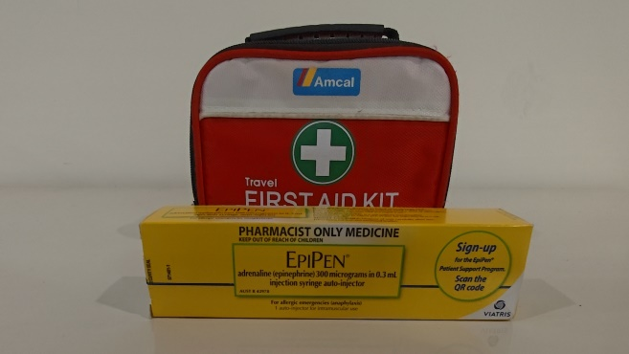
2 One First Aid box is fixed to the wall on the ground floor along the corridor.
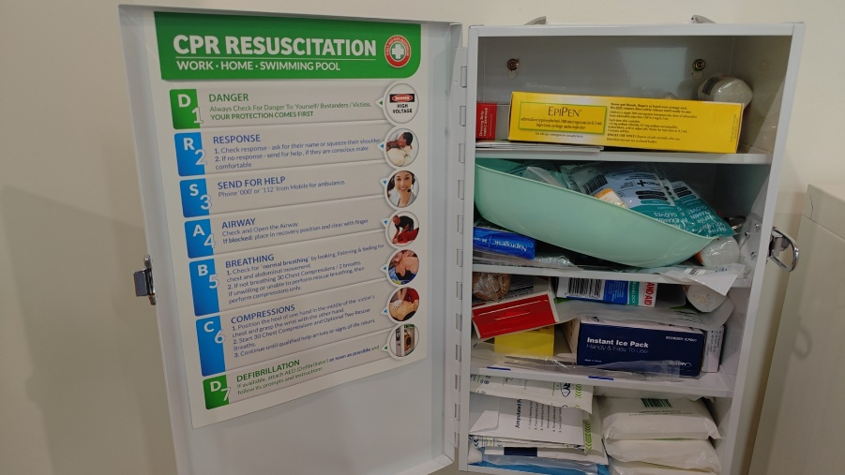
3 One First Aid kit with EpiPen is in the kitchen on the side of the kitchen door in the basement.
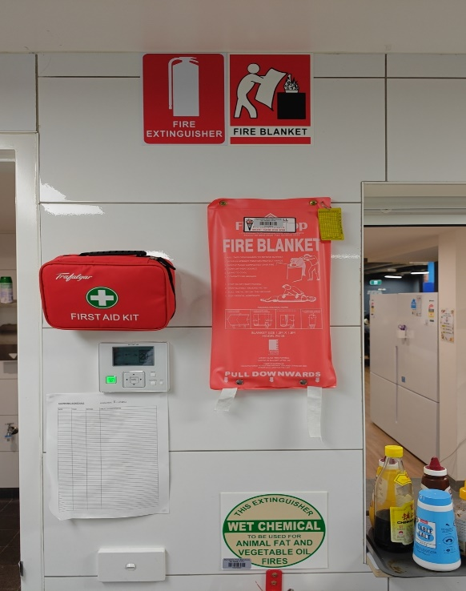

Associated Documents

- MILC Anaphylaxis Emergency Response Procedure
- MILC Evacuation and Emergency Plan
- Ministerial Order 706: Anaphylaxis Management in Schools and Associated Guidelines https://www.education.vic.gov.au/Documents/school/teachers/health/Anaphylaxis_MinisterialOrder706.pdf
- ASCIA: Australian Society of Clinical Immunology – Action Plans for Anaphylaxis https://www.allergy.org.au/hp/ascia-plans-action-and-treatment#r1
- Anaphylaxis Event Register https://www.allergy.org.au/hp/anaphylaxis/anaphylaxis-event-record

