**MILC**

**Introduction to Australian Indigenous Cultures - Students**

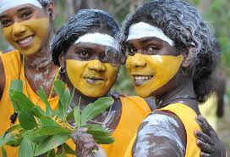

© Creatives Commons

**Understanding Aboriginal Cultures**

It is essential that all staff and students have an understanding of Indigenous culture both locally and nationally. At any time, you may have an interaction with Indigenous Australians. It is essential that such interactions are respectful and appropriate. This document will give you a brief introduction to Indigenous culture and how to have respectful relationships with Indigenous Australians.

MILC acknowledges Aboriginal and Torres Strait Islander cultures date back 60,000. We will remain committed to ensuring that all staff and students understand our true history as an organisation and nation.

Aboriginal culture dates back more than 60,000 years. It existed long before Stonehenge, predates the Pyramids and is older than the Acropolis. This culture can be experienced today in any part of Australia.



*"Aboriginal culture starts with its people. Aboriginal guides open a door into a world that many people don’t know*

*still exists. A world where past, present and future meet."*

- Dr Aden Ridgeway, Gumbaynggirr man and former chair of Indigenous Tourism Australia

**Who are Australia’s Indigenous Peoples?**

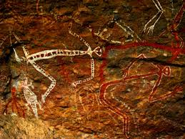

© Creatives Commons

Australia’s Indigenous peoples have lived on the country’s vast lands for tens of thousands of years. They are the world’s oldest living culture, and their unique identity and spirit continues to exist in every corner of the country.

While ‘Aboriginal’ or ‘Indigenous’ may be used to describe Australia’s First Peoples, they see it differently. “We are one, we are different to each other, and we are many,” says Dr Ridgeway. The Indigenous people from the Torres Strait Islands, which are part of the state of [Queensland](https://www.australia.com/en/places/queensland.html), are regarded as distinct from the Aboriginal peoples of mainland Australia and [Tasmania](https://www.australia.com/en/places/tasmania.html).

Torres Strait Islanders come from the islands of the Torres Strait between the tip of Cape York in [Queensland](https://www.queensland.com/) and Papua New Guinea and share many cultural similarities with the people of Papua New Guinea and the Pacific. Currently, Aboriginal and Torres Strait Islander peoples represent less than four per cent of Australia’s population, so an everyday interaction with Australia’s First Peoples is not a given for many non-Indigenous Australians or foreign visitors and students.

Two flags represent the Aboriginal and Torres Strait Islander peoples. The Aboriginal flag, designed by artist Harold Thomas in 1971, is divided into three colours. Black represents the Aboriginal people; the yellow circle symbolises the sun; red represents the earth, the red ochre used in ceremonies and Aboriginal peoples’ spiritual relation to the land.

The Torres Strait Islander flag, designed by the late Mr Bernard Namok and adopted in 1992, has three horizontal panels, with green at the top and bottom (for land), and blue (for sea) in between. These panels are divided by thin black lines representing the Torres Strait Islander peoples. A white dhari (traditional headdress of the Torres Strait) sits in the centre. The five-pointed white star beneath symbolises peace, the five island groups within the Torres Strait and the traditional role that the stars play for seafaring people.

**The Importance of “Being on Country”**

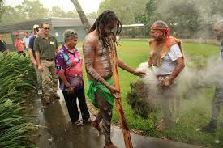

© Creatives Commons

Aboriginal culture is holistic, defined by its connection to family, community and country. In Australia, the idea of “being on country” is central to the Aboriginal worldview.

The land (or country) is what defines Aboriginal people. Aboriginal people from the coast describe themselves as “saltwater people”, those from river areas are “freshwater people”, and those from central arid regions are “desert people”.

“Country is not just a beautiful place, to us it is everything,” says Juan Walker from [Walkabout Cultural Adventures](https://www.walkaboutadventures.com.au/). “It holds our stories, our religion, our customs and our ancestors.”

This is because Aboriginal peoples believe their ancestral spirits emerged from the earth and the sky. These ancestral beings are their hero-creators, and it’s through their journeys that Aboriginal people believe all living things are created. These creation forces are constantly present, hence the strong cultural connection between Aboriginal people, the land and place.

*"This land is sacred. It can feel you when you walk through it. All living things can feel you. There was a time when the ancestors walked through the land and Aboriginal people still feel the ancestors watching them. Knowledge is given from the ancestors to the Aboriginal people through their DNA and the same DNA still exists with Aboriginal people right across Australia."*

- Timmy ‘Djawa’ Burarrwanga from Bawaka Homeland, East Arnhemland

**The Unique Aboriginal World View**

Such an interconnected perspective is radically different to the West where the landscape is seen as separate — or literally outside — of the human experience as we know it. In Aboriginal culture, people and the land merge – they are part of each other.

“Aboriginal culture is sometimes portrayed as very serious and spiritual,” says Dr Ridgeway. “Although it does have this meaningful side to it, Aboriginal people are pretty down to earth. It’s the mix of the practical with the humorous that makes the experience meaningful.”

MILC is committed to providing a culturally safe learning environment that teaches truth-telling. Our priority is to ensure that Aboriginal and Torres Strait Islander voices are heard, valued, respected and influential. We will respectfully embed Aboriginal and Torres Strait Islander cultures within our learning spaces, ensuring pride in identity flourishes and the longest living continuous cultures are celebrated.

We invite Indigenous Organisations to MILC. Students experience Indigenous culture through curriculum and excursions. Our IH teachers will identify the extent to which Aboriginal and Torres Strait Islander histories, cultures and contributions are already embedded in curriculum planning, and identify opportunities for strengthening the representation of this content in the curriculum.

**Aboriginal Nations are as separate as the Nations of Europe or Africa**

The land of Australia is as diverse as its First Peoples. From snowy Mount Kosciuszko in [New South Wales](https://www.australia.com/en/places/new-south-wales.html) to the steamy rainforest of northern Queensland, the continent encompasses desert, temperate and tropical landscape climates. Australia is often thought of as a young country. After all, it was colonised by the British as recently as 1788. However, more than 350 distinct Indigenous social groupings, also called nations, existed just a few hundred years ago - more than three times the number of countries in Europe and Africa combined.

While the term Aboriginal is used as a collective for Aboriginal civilisation and society, Aboriginal nations are as diverse as the travel experiences they offer.

Every part of Australia is considered Aboriginal land and Aboriginal people are bound to a particular territory of land through spiritual links and obligations of care and custodianship to family, community, lore and country. Similarly, Torres Strait Islanders have their own connection to their island home.

“Everyone is different. What I teach you in the Daintree rainforest is one teaching. You go out into the desert, the people out there will teach you a whole new aspect, a whole new way of looking at the world because their country is different. So it’s really important to understand that diversity is a major part of Aboriginal Australia,” says Juan Walker from [Walkabout Cultural](https://www.walkaboutadventures.com.au/) [Adventures](https://www.walkaboutadventures.com.au/).

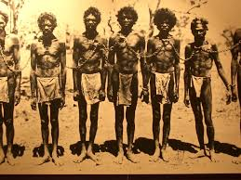 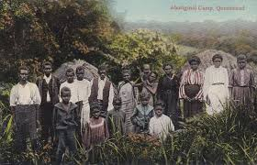

© Creatives Commons

**White Australia, Black History**

From early colonisation and slavery to the White Australia Policy and The Stolen Generations, Indigenous Australians have experienced tragedy and trauma. The British believed that Indigenous Australians needed to become “civilized”, losing their cultural identity. The impact of colonisation still continues. Many of the [languages once spoken are now endangered](https://www.firstlanguages.org.au/for-general-interest), and despite many language revival programs across Australia, Aboriginal people still feel a great sense of loss. Yet their resilience and optimism shine through, and with it, a strong desire to share their stories and culture with national and international visitors.

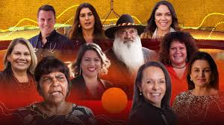

© Creatives Commons

**Indigenous Identity**

Over time people have become more comfortable exploring their Indigenous family past. It is important to note that you cannot presume someone is Indigenous or Non-Indigenous by their appearance. If someone informs you that they identify as Indigenous, please show respect to their culture and customs.

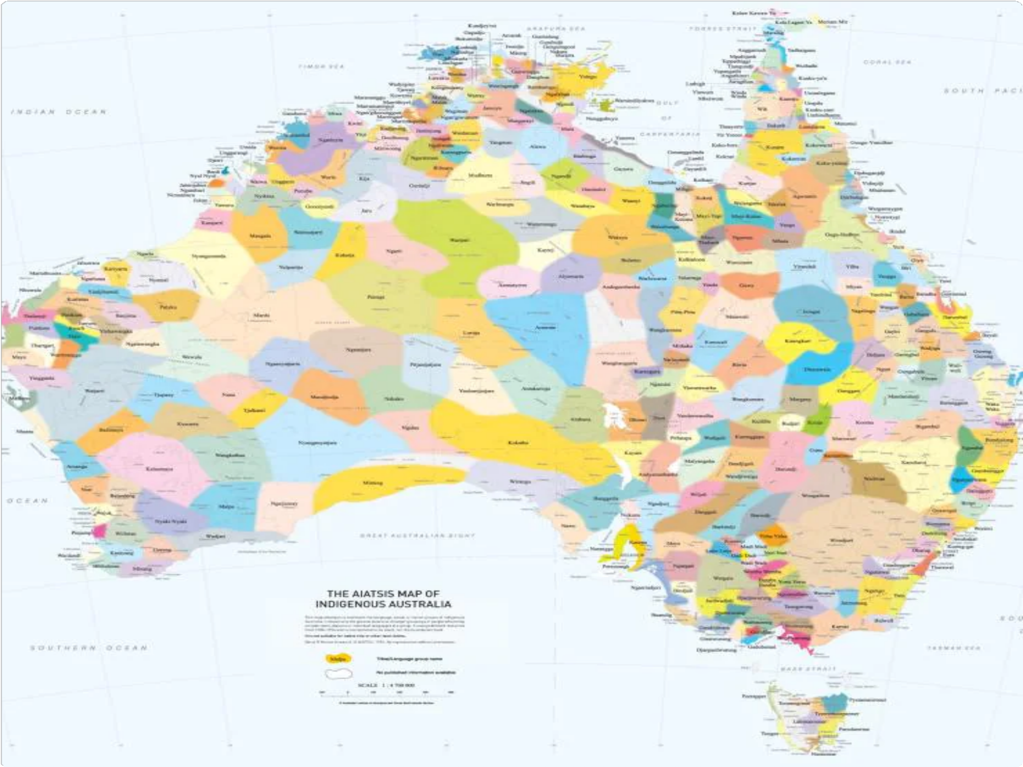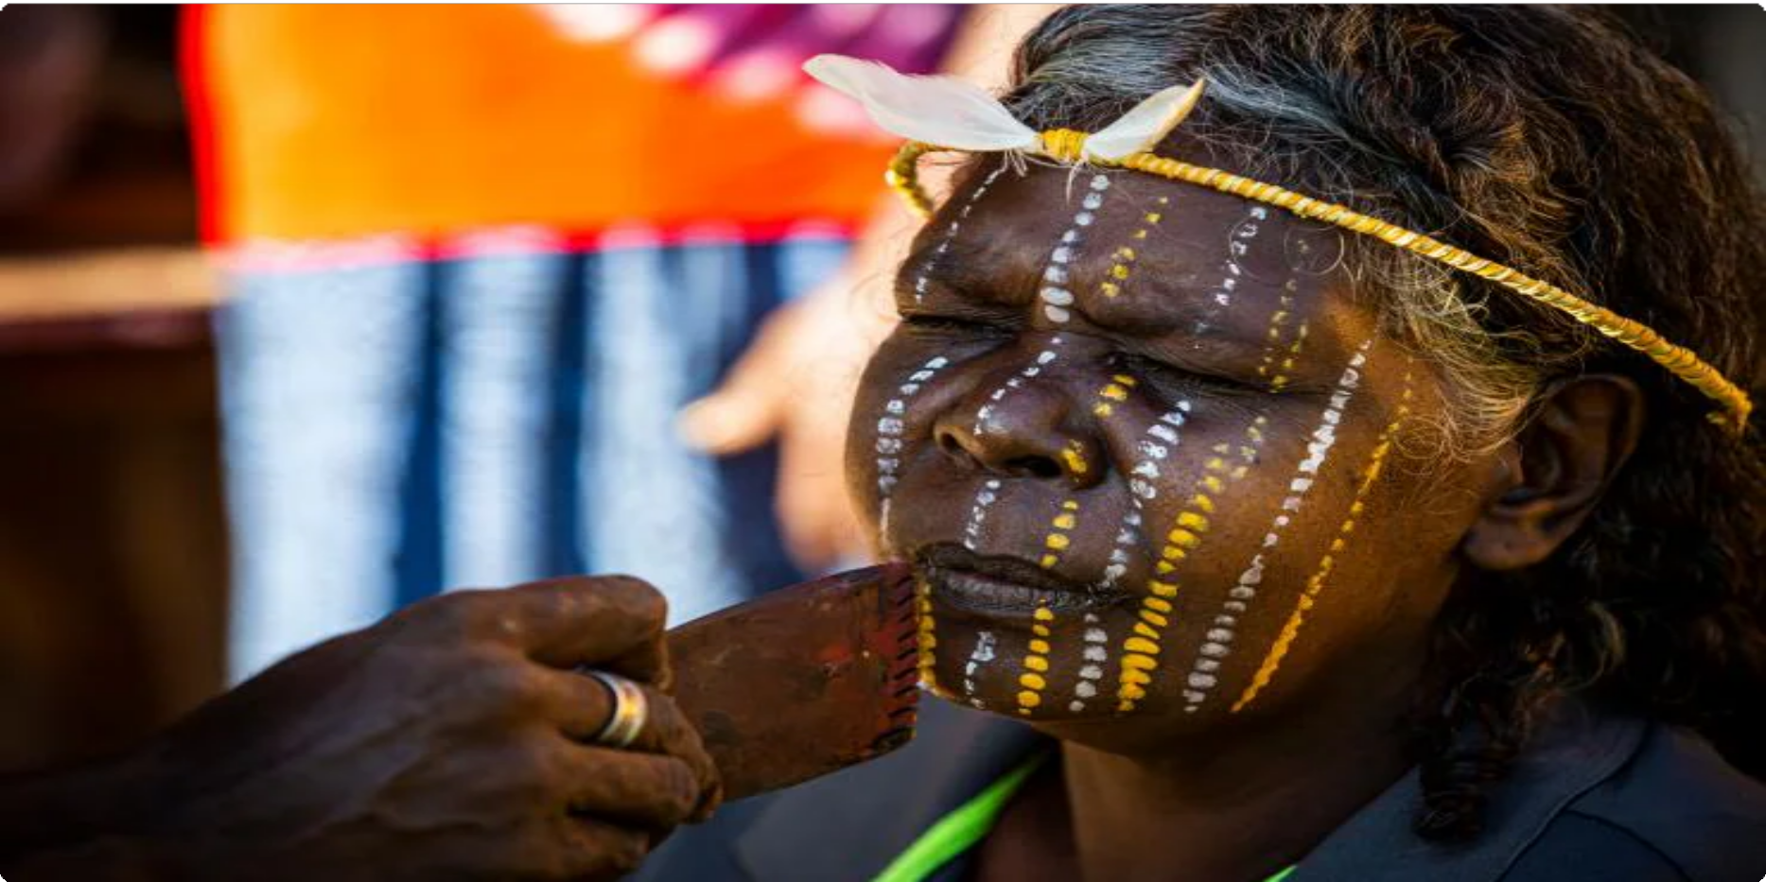

 AIATSIS map of Indigenous Australia* © Australian Institute of Aboriginal and Torres Strait Islander Studies 2017

**Aboriginal Languages, Customs and “Welcome to Country”**

During the early period of colonisation, from 1788, known as the period of “First Contact”, there were between 350 and 750 distinct Australian social groupings, and a similar number of languages. The map above represents the richness of the language, tribal and nation groups of the First Peoples of Australia.

Despite the absence of fences or visible borders, Aboriginal and Torres Strait Islander groups had clear boundaries separating their country from that of other groups. Aboriginal protocol dictates that people are welcomed upon entering a new country.

A ‘Welcome to Country’ can be as simple as using the spoken word, song or walking through a smoke offering, which gives the visitor safe passage and protection. Today, a ‘Welcome to Country’ is becoming a regular part of mainstream Australian life and is a sign of respect of the enduring connection of Aboriginal and Torres Strait Islander peoples to their land, and the land now known as Australia. Non-Indigenous people can undertake an Acknowledgement of Country. Here at MILC we use the following at appropriate occasions, such as events or whole school meetings –

“I would like to begin by acknowledging the traditional owners of the land on which we are meeting today, the Wurundjeri people of the Kulin Nation, and pay my respects to their Elders past and present”.

*\*The above map attempts to represent the language, social or nation groups of Aboriginal Australia. It shows only the general locations of larger groupings of people which may include clans, dialects or individual languages in a group. It used published resources from 1988-1994 and is not intended to be exact, nor the boundaries fixed. It is not suitable for native title or other land claims. David R Horton (creator), © Aboriginal Studies Press, AIATSIS, 1996. No reproduction without permission. To purchase a print version visit:* [*https://shop.aiatsis.gov.au/*](https://shop.aiatsis.gov.au/)

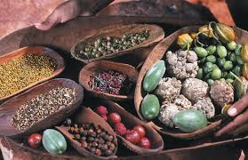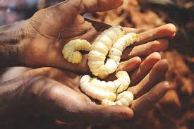  
© Creatives Commons

**Aboriginal Cuisine: Ancient Bush Tucker for Modern Times**

Australia’s diversity means a wide variety of Aboriginal foods and bush tucker is available, and that the seasons do not always follow the traditional Western calendar.

On the [Tiwi Islands](https://www.australia.com/en/places/darwin-and-surrounds/guide-to-the-tiwi-islands.html) there are thirteen seasonal variations. Wurringawunari is the season of the knock-em-downs — when the first dry winds blow. Milikitorinari is the season of hot feet when people gather food in the mangroves.

By closely observing nature, and knowing when certain flowers bloom, fruits ripen, and fish and animals fatten, Aboriginal people have learned to survive for tens of thousands of years. It is this wisdom, handed down over generations, which makes sampling bush tucker today not just a culinary experience — but a cultural journey through time.