MILC Evacuation and Emergency Action Plan
Overview
This Evacuation and Emergency Action Plan establishes guidelines for all reasonably foreseeable emergencies. Because each emergency situation involves unique circumstances, the guidelines provide general guidance only. Thoughtful actions based on situation assessment are always required when responding to an emergency. It is also important to note that emergency guidelines do not necessarily represent sequential series of steps.
MILC is committed to maintaining safe standards in regard to our premises.
- the building exits will continuously be kept clear of obstructions
- assembly points are designated and have appropriate access to emergency equipment
- there is access to facilities and grounds for emergency vehicles.
Safety and health are the overriding priorities in all emergency situations. Think before you act and if you see something, say something!
First Aid and EpiPen
In case there is an emergency of First Aid, including anaphylaxis, First Aid kits with EpiPens are provided in the building at locations indicated below.
One mobile First Aid kit with EpiPen is available at the reception for excursions, the kit is to take out with the group.
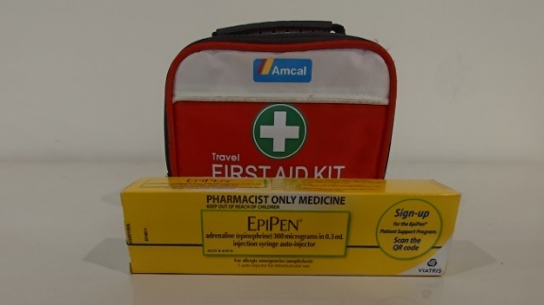
One First Aid box is fixed to the wall on the ground floor along the corridor.
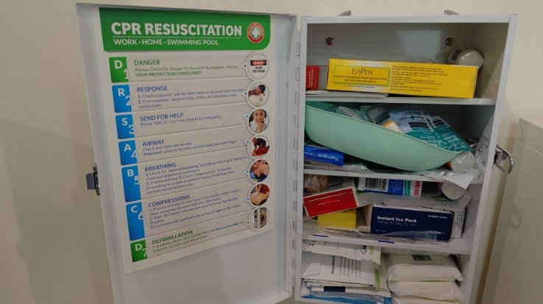

One First Aid kit with EpiPens is in the kitchen on the side of the kitchen door in the basement.
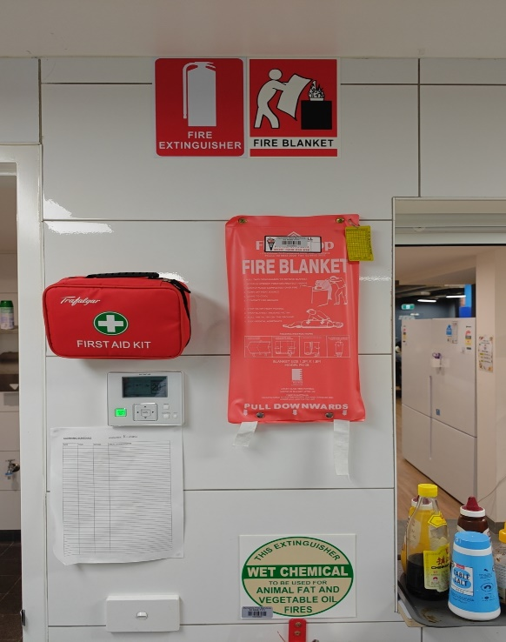

Evacuation Diagram Plan (EDP)
The EDP can be found on each floor in multiple locations that is easy to be found. It is either on the wall next to a lift or next to the door of the stairwell on each level.
Each EDP has a clear evacuation route to guide you through to the assembly area.

Assembly Area – See Icon  in each diagram, the assembly location is where we go when an emergency is happening.

Alerting all personnel in the building
The following apply during fires that require evacuation:
- The fire alarm will be activated and personnel will calmly evacuate using designated escape routes on the wall in different location of the building.
- Personnel will look into rooms as they leave the site and notify other personnel to exit; do not delay your evacuation for this purpose.
- Using the fire box on the ground floor near the entry to report to fire / police only if it is safe to do so, otherwise only do this when you are safely at the assembly area.
- Personnel will assemble and remain in the evacuation Assembly Area. Leaving the group or failing to report to the evacuation Assembly Area can cause unnecessary effort locating personnel believed to be missing.
- Immediately notify your building manager of missing or unaccounted for personnel.
- Stay alert and listen for instructions.
- Await guidance to disperse, return to the building or take additional measures.
- In the event of a Medical or other emergency that does NOT require evacuation, CALL 000 to alert Police and notify the Emergency Coordinator.

ROLES & RESPONSIBILITIES
Building Manger (Michael Xiang: 0415596608, Roger Shen: 0432331789)
Building Managers assume responsibility during an emergency.
Responsibilities:
- Ensure the dissemination, implementation and updating and reviewing of this Plan.
- Conduct exercises as needed to optimize our personnel emergency response.
- Conduct and document an after-action review following any emergency event and provide a copy to the organization’s Director (Roger Shen: 0432331789).
- This plan will be maintained in accordance with VRQA regulation and all other regulators.
Floor Duty Officer: any adult employees that is on the floor (Caretakers, teachers, other MILC officers)
Duties/Responsibility during an Emergency:
- Ensure Floor duty officers in charge initiate and complete accountability and/or evacuation.
- Coordinate the orderly evacuation of personnel when needed.
- Obtain accountability for other personnel following the incident and/or evacuation.
- Provide Emergency Response personnel with necessary facility information.
- Put on a vest, take your mobile and copy of the plan and ensure accountabilities for all personnel in your zone if it is safe to do so.
- During an evacuation, direct people out of your zone and exit via the stairwells; remind employees NOT to use the elevators.
- Upon arrival at the Assembly Area, confirm all personnel are present or are otherwise accounted for (e.g., illness, travel, vacation, meetings).
- Immediately report to corresponding authorities.
All other personnel (contractors, 3rd party users, clients and students)
- Understand all information in the EAP.
- Read updates to the EAP when provided.
- Know the names and contact info for personnel serving as building managers, floor duty officers, where to find evacuation routes and procedures, Assembly Area location.

GENERAL INSTRUCTIONS FOR REPORTING EMERGENCIES
Summon emergency assistance by CALLING 000
Be prepared to provide the following information:
- Your name and location.
- Phone number from where the call is being made.
- Location of the emergency, including facility name, full address.
- Type of emergency:
- Medical
- Fire
- Confined Space Rescue
- Hazardous Material
- Criminal Act
• Other important Information:
- Number and condition of victims.
- Location and extent of situation, hazard, fire, etc.
- Involvement of Hazardous Materials (as available, give product name and/or describe any markings, labels or placards).
• What is needed
DO NOT HANG UP FIRST.
Let emergency personnel hang up first.
After the call, station someone to direct Emergency Response personnel to the scene of the emergency

Appendix: EDP on different locations of the MILC site
Ground Floor Back door EDP
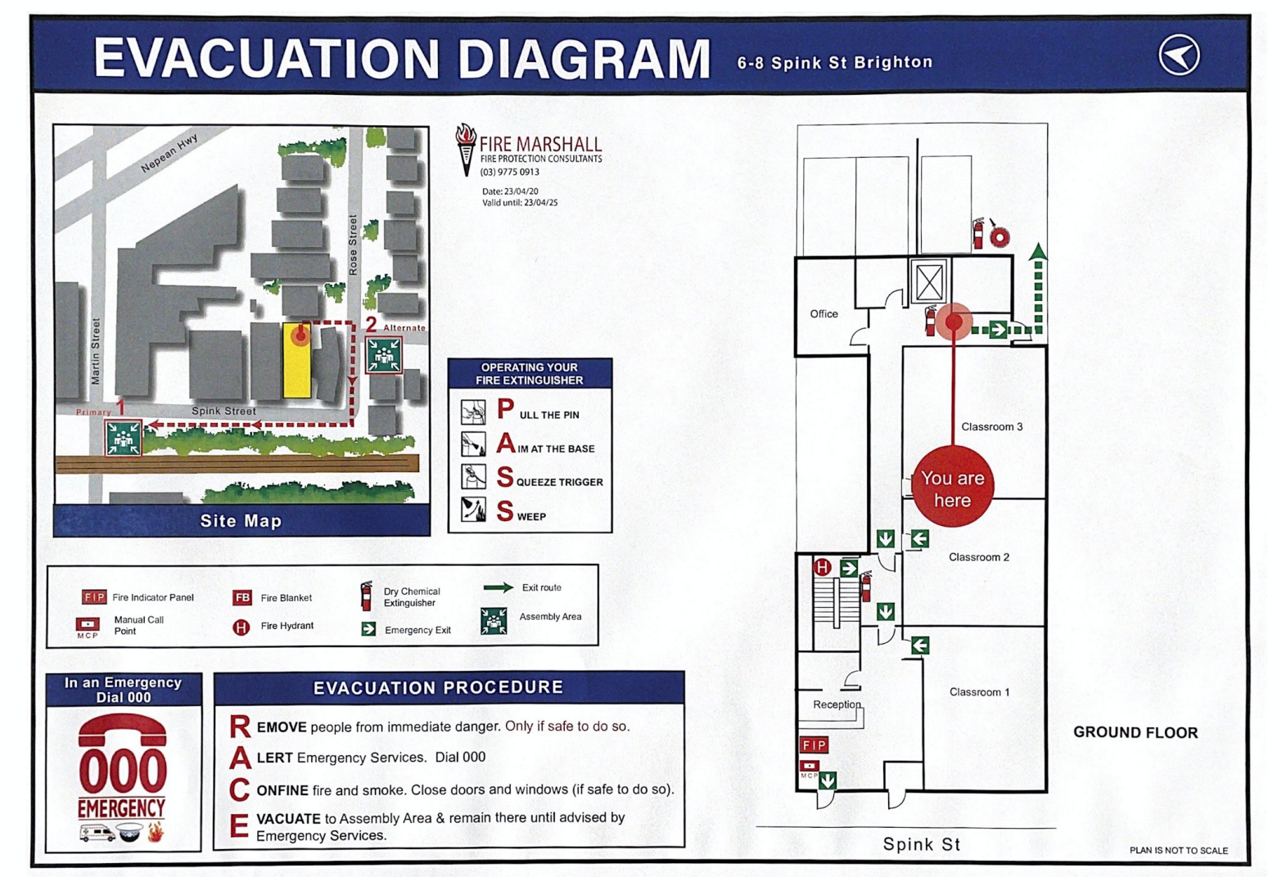

Ground Floor corridor
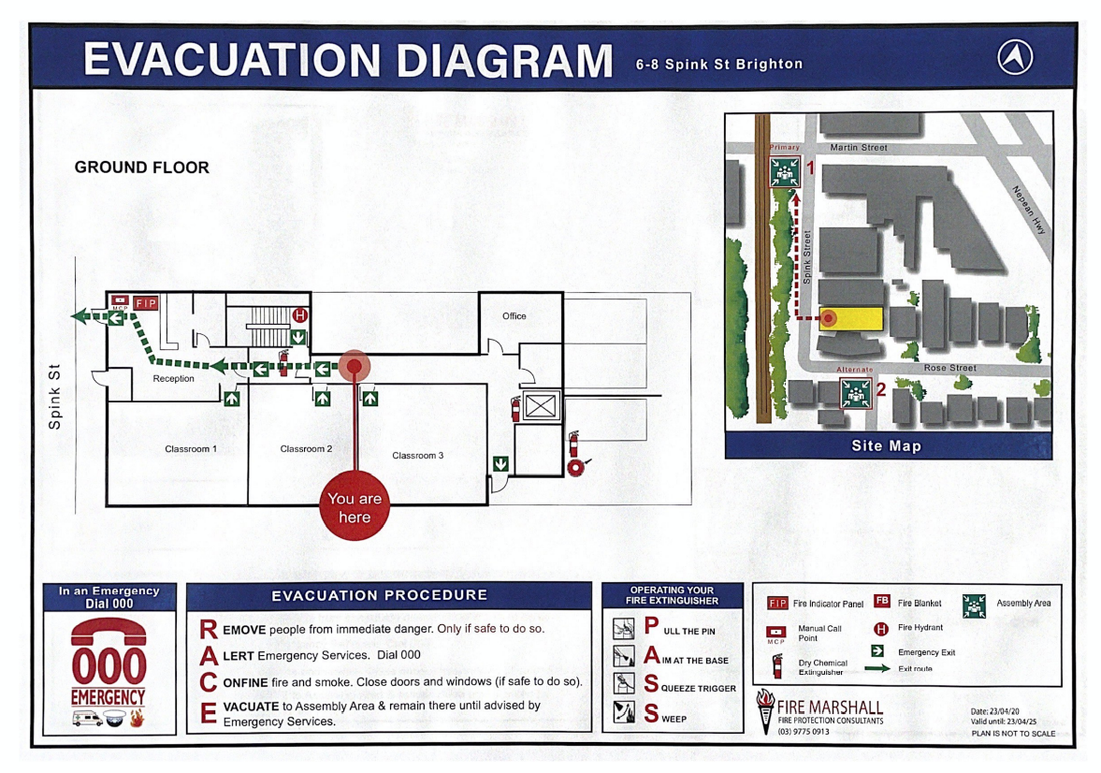
Ground floor- front entrance
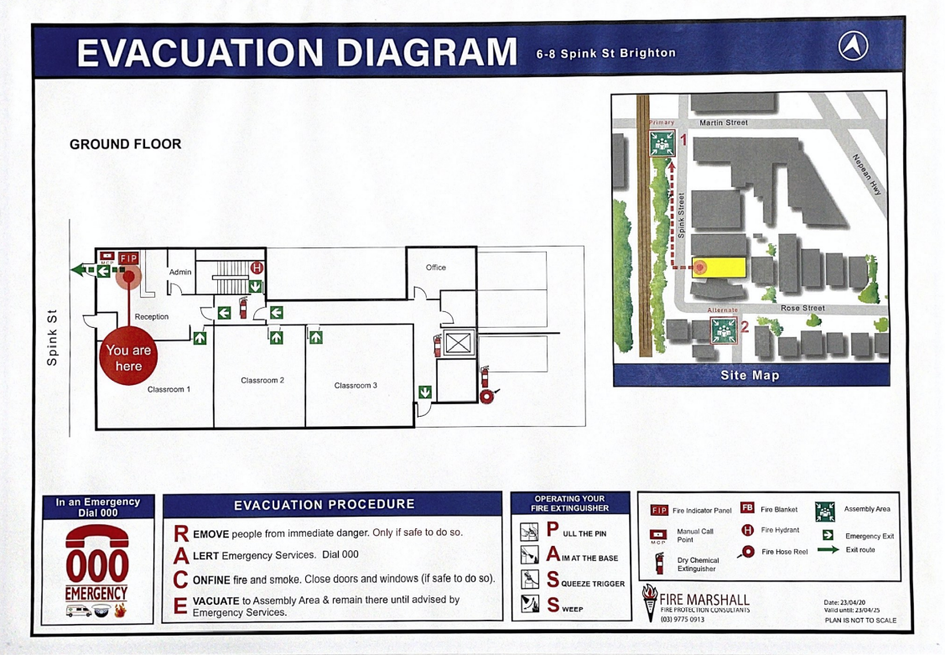

Ground floor stairwell
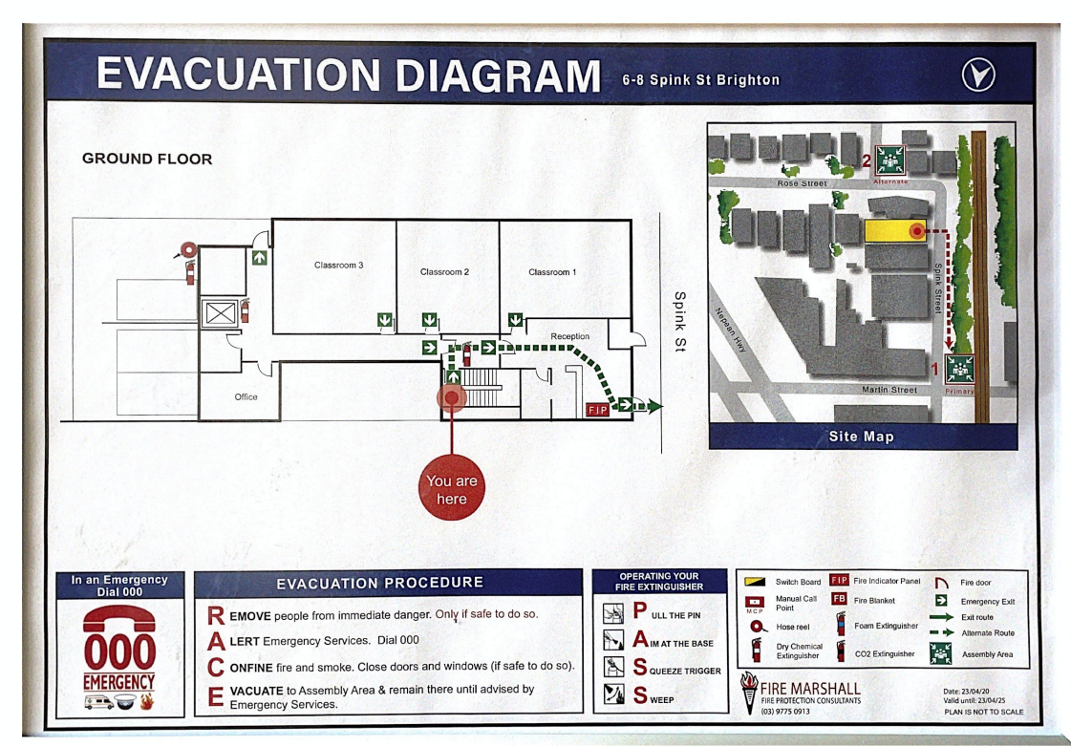

Level 1 Play area
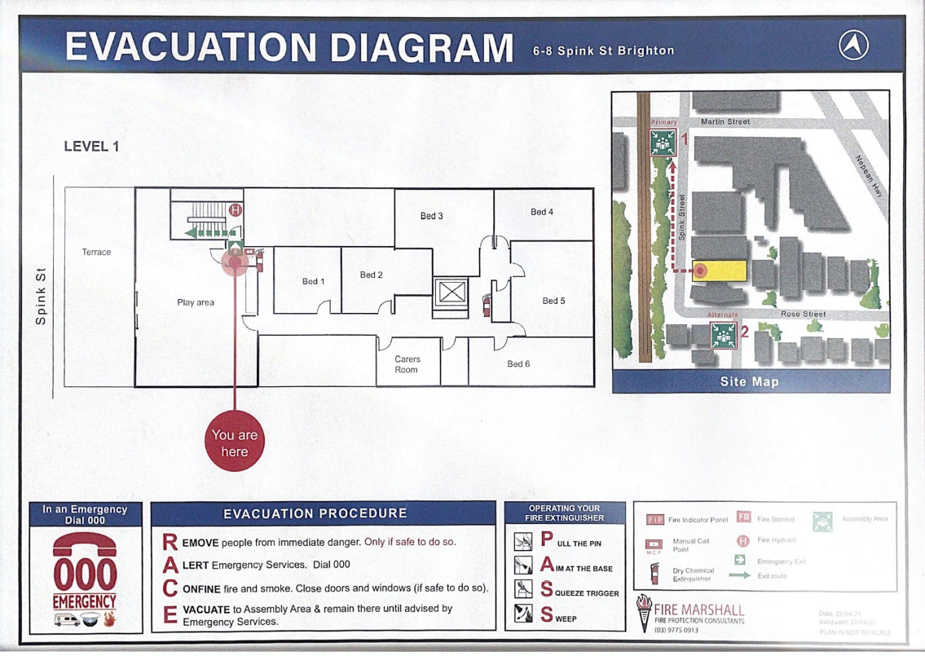

Level 1 lift
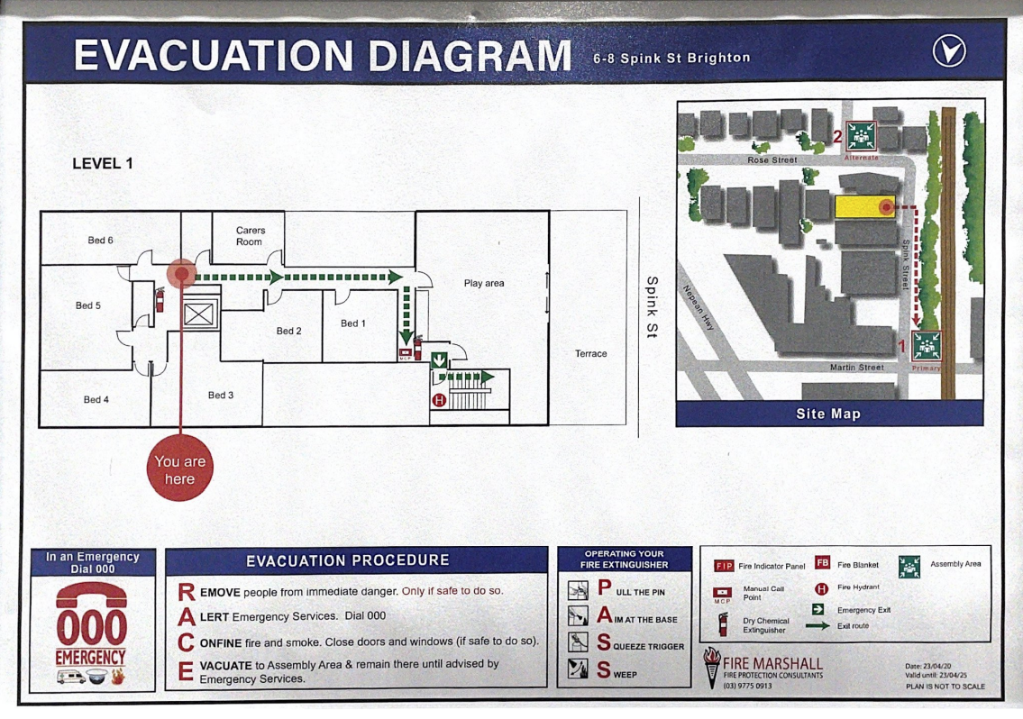
Level 2 stairwell
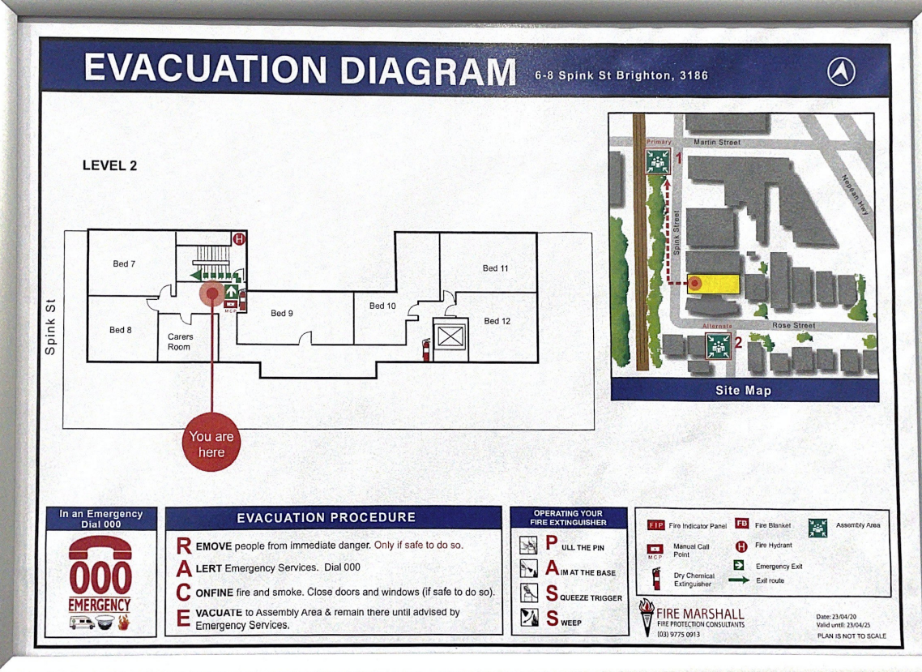

Level 2 lift
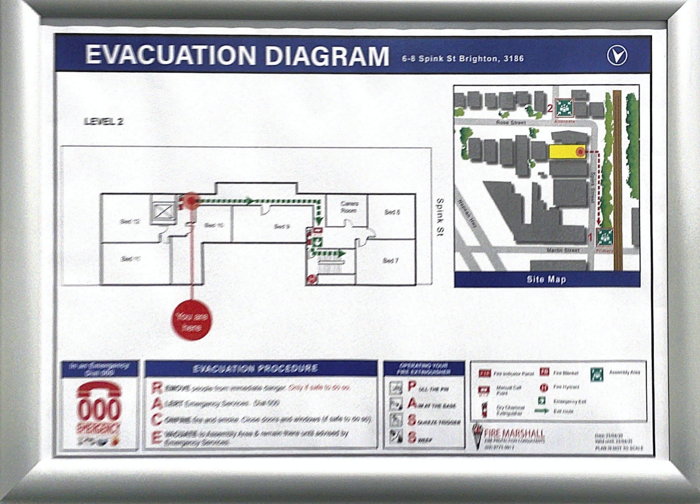

Basement lift
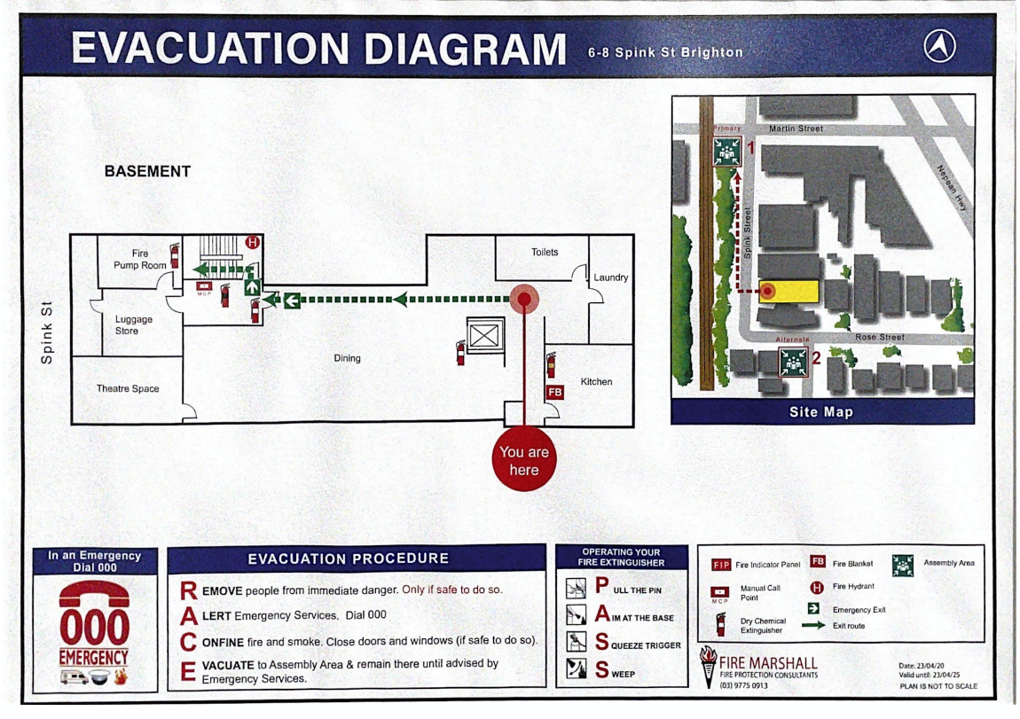

Basement stairwell
